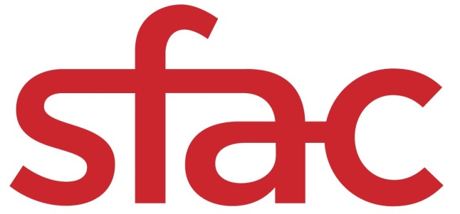
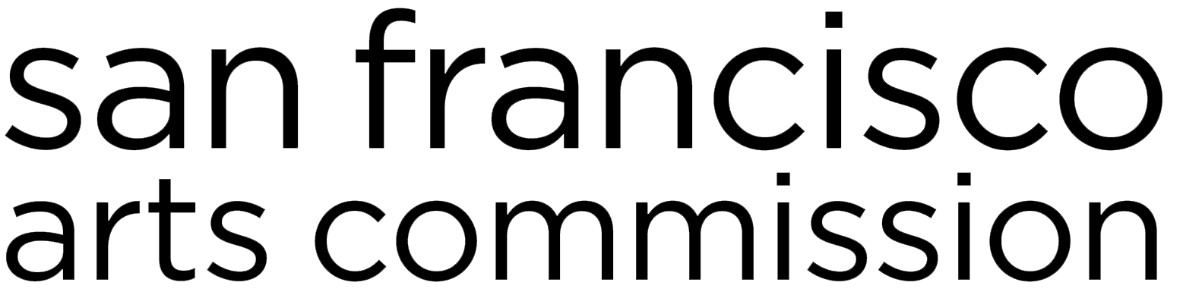

Artistic Legacy Grant (ALG) | Grant Application
FY2017-2018 GRANT CYCLE

APPLICATION DEADLINE: Wednesday, March 7, 2018, 12 p.m. noon PST

SUBMISSION INFORMATION: Email complete application and additional attachments in a single PDF to sfac.grants@sfgov.org

Include “18ALG: (organization name)” in the email subject line.
Example: 18ALG: Pegasus and Unicorns United for the Arts

For questions about ALG, contact Director of Community Investments Barbara Mumby at Barbara.Mumby@sfgov.org or 415-252-2215.

San Francisco Arts Commission  Tom DeCaigny  Director of Cultural Affairs  401 Van Ness Avenue, Ste. 325  San Francisco, CA 94102  tel 415-252-2590  fax 415-252-2595  sfartscommission.org  facebook.com/sfartscommission  twitter.com/SFAC | *A translation of this grant application is available upon request; however, only applications in English will be accepted.  Una traducción de esta solicitud de aplicación está disponible a petición; sin embargo, solamente se aceptarán solicitudes en inglés. Favor comunicarse con Kate Patterson-Murphy al 415-252-2229 ó kate.patterson@sfgov.org para una traducción al español.  本資助申請表的翻譯版本將應請求而提供；但僅受理英文版本的申請表。 查詢詳情，請聯絡311。  Ang pagsasalin sa Tagalog ng aplikasyon para sa pagkalooban na ito ay makukuha kung hihingilin. Ngunit ang aplikasyon sa Ingles lamang ang aming tatanggapin. Para sa tulong, maaring i-contact si Cece Carpio, 415-252-2217 o cece.carpio@sfgov.org.
Application Checklist
Please submit a single PDF containing the following documents in the order listed:

Application Form: The application form includes the application checklist, contact information, eligibility, project information, and narrative questions (alignment with SFAC goals, artistic history, pivotal juncture, and organizational sustainability). Do not include the cover page above with your application.

Artistic Director(s) resume or CV. See narrative section below for guidance.

Letter(s) of support (1 min. / 3 max.). See narrative section below for guidance.

DataArts SFAC Funder Report & Budget Notes. See narrative section below for guidance.

Proof of San Francisco Corporate Address: The organization must have a corporate address in San Francisco to be eligible for funding. Post Office Box addresses will not be accepted. Please attach proof of corporate address in the form of a recent (no more than three months old) bill or statement, such as: telephone bill; electrical bill; bank statement. The proof of address must include the name of the applicant.
If the applicant has a fiscal sponsor, they must provide proof that their fiscal sponsor has a corporate address in San Francisco AND that they applicant has a corporate address in San Francisco. For fiscal sponsee proof, this could be in the form of a letter from the fiscal sponsor stating that they accept mail on behalf of the fiscal sponsee at their corporate address. Please contact SFAC staff if you have questions this requirement.

Proof of good standing with IRS: Visit https://apps.irs.gov/app/eos/pub78Search.do and select the search to organizations that “Are eligible to receive tax-deductible charitable contributions.” Please include the page that shows your organization listed and attach to the single PDF submission

Note: Before you submit your application, please remember to insert the name of your organization in the footer below.

APPLICATION FORM

Contact Information

Grant Applicant Name:
Contact Person & Title:
Corporate Address in San Francisco:
Mailing Address if Different:
Day Phone: Mobile:
Email:
Please provide a valid email. Important grant information will be sent via email.
Number of the supervisor’s district where the organization is located:
District numbers can be found at: propertymap.sfplanning.org

Fiscal Sponsorship Information (if applicable)

Name of Fiscal Sponsor:
Contact Person & Title:
Corporate Address in San Francisco:
Mailing Address if Different:
Day Phone: Mobile:
Email:
Please provide a valid email. Important grant information will be sent via email.

Note: Before you submit your application, please remember to insert the name of your organization in the footer below.

Eligibility

Is your organization a 501(C)(3) arts organization? All organizations are required to have a 501(C)(3) and be in good standing with the IRS as a tax-exempt organization or have fiscal sponsorship through a San Francisco based 501(C)(3) organization. Please note: If you do not designate the appropriate status, this could adversely affect your ability to receive funding if you are awarded a grant. yes no
- If you are using a fiscal sponsor for this grant, you must check NO. Please fill out the above information to list the name of your fiscal sponsor, their San Francisco address, contact name, phone and email address.
- If your organization has its own 501(C)(3) designation and does not rely on the support of a Fiscal Sponsor, you will check YES.
- Please note: If you do not designate the appropriate status, this could adversely affect your ability to receive funding if you are awarded a grant.

Is your organization clearly focused on the production, development, and/or presentation of arts activities in San Francisco? The organization’s mission statement must be clearly focused on the development, production, and/or presentation of arts activities in San Francisco. yes no

Is your organization a part of another City agency or department? The applicant organization cannot be part of another City agency or department. yes no

Attach proof of good standing with the IRS. See application checklist above for instructions

Attach proof of San Francisco corporate address. See application checklist above for instructions.

Check this box to confirm you are not in default for any grants or loans from: SFAC, other City departments, Northern California Grantmakers Arts Loan Fund, Northern California Community Loan Fund, the Community Arts Stabilization Trust, or the Center for Cultural Innovation.

Project Information

Grant Request Amount:
Organizations may ask for no more than 50 percent of the three-year average of their operating budget income (determined by the line: Revenue Less In-kind minus Non-operating Revenue in the SFAC DataArts Report) or up to $40,000, whichever is less.

Project Summary: Provide a brief summary of the proposed project in 75 words or less that starts with "SFAC funds will be used to support..." For example: SFAC funds will be used to support succession planning of the artistic director.”

Alignment with SFAC Goals (25 points)

What is your organization’s mission statement? Please describe even if disclosed elsewhere in application. The organization’s mission statement must be clearly focused on the development, production, and/or presentation of arts activities in San Francisco. (250 words max.)

Priority funding goes to organizations that foster artistic expression deeply rooted in and reflective of historically marginalized communities. Using both the Cultural Equity Endowment Legislation and the Grantmakers in the Arts’ “Racial Equity: Statement of Purpose,” these communities include: African and African American; Latino/a; Asian and Asian American; Arab; Native American; Pacific Islander; Lesbian, Gay, Bisexual, Queer; Transgender and Gender Variant People; People with Disabilities; and Women. (SF ADMIN. CODE CHAPTER 68: CULTURAL EQUITY ENDOWMENT FUND. Sec. 68.6. PROJECT GRANTS).
We recognize that some marginalized communities may not be listed here and encourage applicants to articulate and provide supporting evidence about the marginalization for any community not named above. Please also note the legislation pertains to marginalized communities and not fringe artistic disciplines.

Who does your organization serve and why? How does your organization meet the needs of the communities you serve? This should expand upon your mission statement. Applicants are encouraged to refer to demographic data and community engagement strategies where appropriate. (400 words max.)

Please select one of SFAC’s goals for equitable grantmaking that best align with your organization:
Capacity Building: Build capacity, resilience and economic viability of individual artists from historically marginalized communities.
Accessibility: Provide a space to access art and creativity for historically marginalized communities.
Cultural Integrity: Create or present work that demonstrates integrity and ethical use of material with specific cultural origins and context.
Intersectionality: Address how race, gender, sexuality, ability, socioeconomic status, immigration status, religion, class, etc. are interconnected through artistic programming or process.
Using detailed explanation and examples, describe how your organization aligns with the selected goal. Applicants should expand upon the organization’s core philosophies, not the proposed project. (300 words max.)

Describe the leadership team and staff’s relevant experience and qualifications working in the communities you serve. Please answer in relation to the organization’s leadership team (such as the executive director, managing director, artistic director, and/or board president) and not project staff (if different from core staff). (300 words max.)

Artistic History (25 points)

Describe the artistic leadership and how they have contributed to the vitality of the organization. Highlight major accomplishments indicative of the organization's general trajectory. Outline moments in the organization’s history that exemplify the implementation of its mission, values and vision. Additionally, highlight a few pivotal organizational accomplishments, which have some relevance to the project being proposed (if applicable). A well-articulated answer to this question helps to provide context while conveying confidence in the organization’s ability to successfully carry out the proposed project. (400 words max.)

Attach Artistic Director’s resume or CV. Resumes or CVs help panelists determine the depth and breadth of an artistic director’s professional career. Resumes or CVs should be no more than three pages in length and highlight the breadth of the artistic director’s work and impact within the designated community(ies) served. Organizations that are applying on behalf of multiple artistic directors can submit a Resume or CV for each of the directors, no more than three pages each.

Attach up to 20 photos that span the artistic director’s time with the organization. For each photograph, please include the following information:
- Date photograph was taken and photograph credits (if known)
- If the photograph is part of a larger artistic presentation/show, please include (if known): title of work, date, dimensions or total duration, brief description to contextualize the work; company/artists involved if the work was done in collaboration with other organizations, presenters, or artists. Please state your role in the production.
- We strongly encourage inclusion of anecdotes in relation to the photographs. If the organization is awarded the grant, SFAC staff may choose to reference these anecdotes and/or photographs as part of the Artistic Legacy Award presentation.

Attach at least one and no more than three letters of support. Please attach letter(s) of support (one page max.) from representative(s) of community and/or neighborhood partner organizations or individual(s) (including artists, community participants or patrons). The letter(s) should convey the depth and breadth of the relationship and how the organization and artistic director has impacted the respective community partner organization and/or individual, as well as their reason(s) why they believe the applicant should be awarded the Artistic Legacy Grant. This letter should be written by, and reflective of the “voice” of the community partner organization or individual. All letters should include a wet signature from the letter writer; letters from organizations and/or authorized representatives should be submitted on the organization’s letter.

OPTIONAL: Provide URL(s) to a video work sample(s) (via Vimeo or YouTube) of no more than four minutes total run time that show(s) a breadth of the artistic director’s contributions to the organization. You may submit multiple videos, but the run time must add up to no more than four minutes total for all the videos. The video will be considered during the application evaluation process in its entirety, but will not be included in the overall score. In other words, you will not be docked points if you choose not to include video work samples. If you do choose to provide video work sample, however, please include the following information:
- Date video was taken and video credits (if known)
- If the video is part of a larger artistic presentation/show, please include (if known): title of work, date, dimensions or total duration, brief description to contextualize the work; company/artists involved if the work was done in collaboration with other organizations, presenters, or artists. Please state your role in the production.
- We strongly encourage inclusion of anecdotes in relation to the video(s). If the organization is awarded the grant, SFAC staff may choose to reference these anecdotes and/or video(s) as part of the Artistic Legacy Award presentation.

Pivotal Juncture (25 points)

Describe the current state of your organization and how the artistic leadership has worked to ensure the sustainability of the organization. Strong applications are those that demonstrate a thorough understanding of the overall state of the organization as well as particular internal or external hurdles or opportunities that exist at this time. (400 words max)

Describe the continuing impact the organization has upon the community served. Describe your desired outcomes and how you will measure the impact of the initiative on the organization and community stakeholders. Clearly articulated outcomes will help panelists understand the impact of the proposed project and how you will measure success. Strong applications demonstrate that the continuance of its work has a direct impact on the community served as well as on the broader arts ecosystem. (300 words max)

Organizational Sustainability (25 points)

Describe future challenges and how the organization and Board of Directors are working to address these challenges. Strong applications are those that demonstrate a thorough understanding and some strategy for overcoming the challenges of the organization, that the Board of Directors is invested in strategizing the future of the organization, as well as particular internal or external hurdles or opportunities that exist at this time. (400 words max.)

Attach DataArts SFAC Funder’s Report and Notes. Applicants are required to submit an SFAC Funder Report from the DataArts website culturaldata.org that includes the three most recently completed fiscal years. If six months have passed since your year closed, it should be entered into your DataArts profile.
Remember to include typed budget notes that correspond with your DataArts SFAC Funders Report. Panelists will use your DataArts SFAC Funder Report to better understand your organization’s financial position and health. If you have already created an SFAC Funders Report for any of our other FY2017-2018 grant cycle categories (i.e. Organizational Project Grants, Cultural Equity Initiatives (CEI), etc.) please submit this. Otherwise, please use the CEI template for generating the report.
Please note: For more information about the SFAC Funders Report, please call the DataArts help line at 1-877-707-3282. The staff person on the DataArts help line will walk you through generating this report so that you can upload it to the GMS. The report includes instructions on the cover about the required budget notes.
- Organizations with a reserve or operating surplus should provide notes that explain your reserve policy or plans for use of the surplus.
- Organizations with accumulated deficits must provide notes that detail how the deficit developed and plans for the deficit reduction.
- Organizations that hold outstanding loans or have defaulted on loans must include notes that provide sufficient explanatory details.

