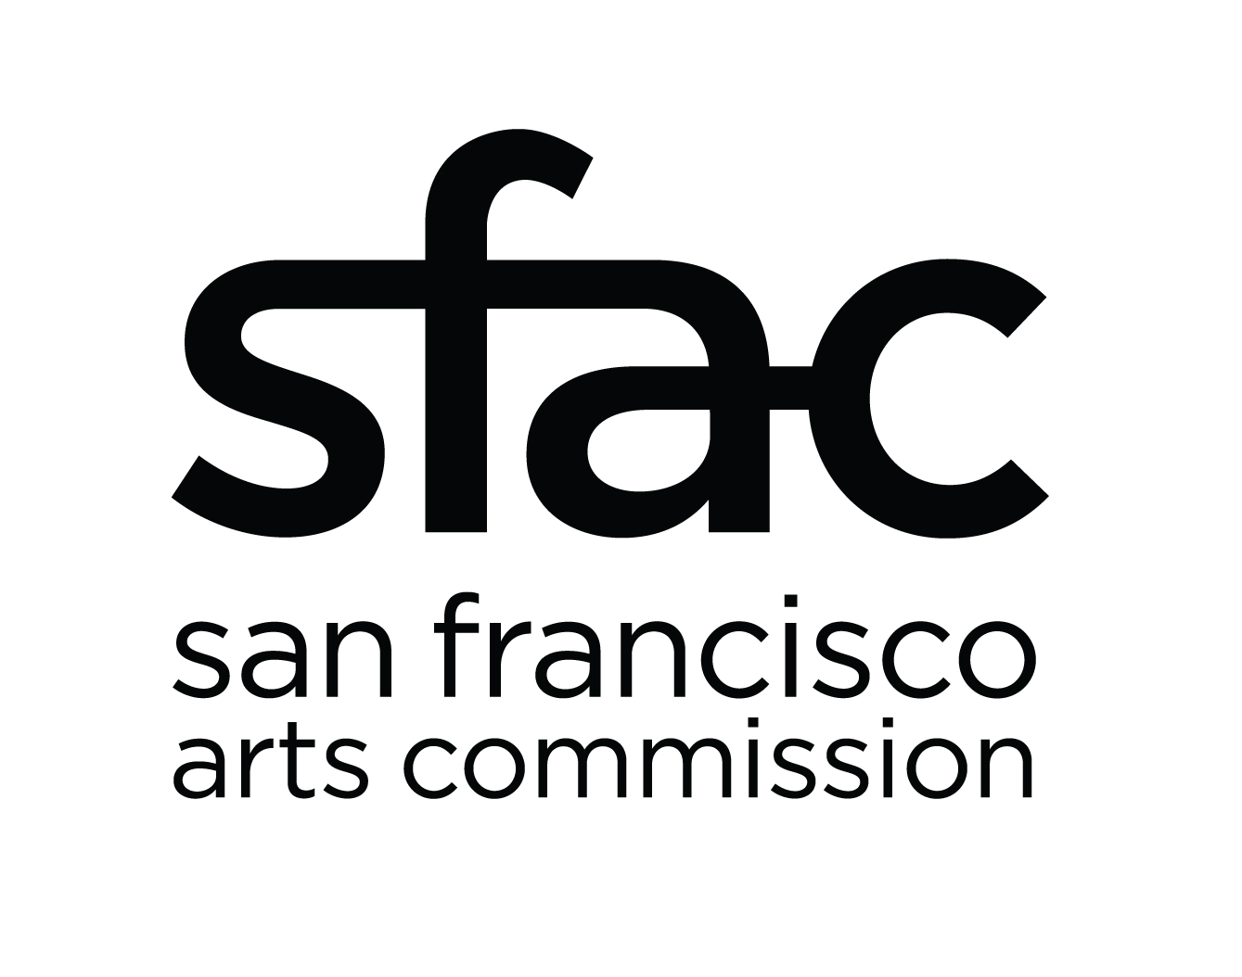

San Francisco Arts Commission

Community Investments

Grantee Name: ______________________________

FINAL REPORT
Creative Space – Facilities (CRSP–Facilities)

Please submit by email or postal mail to your program officer at San Francisco Arts Commission, 401 Van Ness Avenue. Suite 325 San Francisco, CA 94102. Please note that any invoices for remaining grant funds (Appendix E) must be received as a hard copy with original signature. E-copy ok for other documents.

Checklist of required elements:
Please be sure to include all elements in your submitted report. Reports are considered incomplete until all required pieces have been received.

Final Report Form (this document)

Grant Plan Progress Report (separate attachment)

Expense Report (separate attachment)

Financial Documentation (invoices and proof of payment)

Project Documentation
Please send at least one digital image documenting your project to grants staff. Include any relevant credits. By sending an image, you are granting the Arts Commission permission to use it in future SFAC reporting, archival and promotional information.

Current Insurance Certificates
Remaining funds cannot be disbursed unless we have current General Liability, Workers’ Compensation, and Auto insurance certificates with the proper information. All General Liability certificates must name “The City & County of San Francisco, its officers, agents, and employees” as additional insured and the “San Francisco Arts Commission, Attn: Community Investments, 401 Van Ness Ave, Suite 325, San Francisco, CA 94102” as certificate holder.

If you requested a General Liability waiver, you will need to submit either required document at least two weeks prior to your public event:

Event insurance (please provide a copy of your certificate that names “The City & County of San Francisco, its officers, agents, and employees” as additional insured and the “San Francisco Arts Commission, Attn: Community Investments, 401 Van Ness Ave, Suite 325, San Francisco, CA 94102” as certificate holder); or
Venue confirmation of coverage (A blank form is provided as a separate attachment with the final reporting packet. It should be signed in advance of your event by an authorized staff of your venue who can confirm coverage of your public event).

If you have a remaining balance on your grant and you are not in default, please include a signed, hard copy of your invoice (Appendix E) to receive a disbursement on your grant:
Appendix E: Signed Invoice (separate attachment)

I. Project Narrative:

- Summarize the outcomes of the project reflecting on the project goals. (200 words max)

- How did the project go logistically and financially? What lessons did you learn? (250 words max)

- How has the project impacted the organization’s budget and staffing? (200 words max)

- How has the project impacted your artists, community, and audience? Level 2 awardees, please add how this project benefits your neighbors and the local arts community. (250 words max; 300 words max for Level 2)

- Refer to the evaluation methods you described in your grant application and provide your assessment of the results. (300 words max)

- Please list press mentions your project received. This may be links to the coverage, scanned e-copies of press clippings in print, or a list of press mentions if physical and web documentation don’t exist. (Add rows as needed.)
Press Mention News Outlet | Web link or  E-copy File Name

- Photo Documentation: Please provide relevant photo credits and captions in the space below. (Add rows as needed.)
Image File Name | Photo Credit | Caption

For Level 2 awardees:
- Provide a list of your board members with their financial contributions to this specific project and date of contribution.

- Provide information on how the 20 percent match was met within the specified window of October 15, 2015 to June 30, 2017.

Check this box if you are willing to participate in a pilot survey 6 months out from the close of your grant. This survey will ask questions to measure the impact of the facilities work done on your building and help us better assess the city’s need for capital improvement funds and how our funding can make an impact on the arts ecosystem.

I certify that, to the best of my knowledge, that the information contained in this final report is true and correct.

Signed: ________________________________________Date:

